**Project Team 12 - Electricity Billing System**

Team Members:

1. Anchal Atlani
2. Anushka Kamalapurkar
3. Sagar Kulkarni
4. Gaurav Mahadik

**Context:**

The Electricity Billing System will give a single platform to customers through which they can pay and view their bills of any service provider listed in the system

**Objective:**

The main objective of the project is to develop a database system that will help a customer to register under a service provider, view and pay electricity bill. Apart from this a customer can also change service provider, upgrade to use solar net metering, view historic payments, peak and off peak hours and billing cycle.

**Scope:**

1. **Customer Registration**: Customer register under the system under a specific service provider for smart meter or solar net meter.
2. **View and Pay bills**:
3. Customer can pay and view historic bills.
4. Customer can check the unit consumption of the selected period.
5. Customer can view the off peak and peak hours for the area.
6. **Stop or Change the connection**: Customer can switch to other service provider and customer can deregister from the system.
7. **Admin can add Service Provider/ Customer:** Admin can add any new service provider or new customer.
8. **Admin modify the tariff rates:**

a. Admin can modify the tariff rates of any service provider.

b. Admin can modify the peak and off peak hours corresponding to any service provider in any area.

## **ENVIRONMENT SETUP:**

We are using MySQL Database management System. For making connection to MySQL server we are using mysql-workbench-community-8.0.12-winx64 client. For user interface and database connectivity we are using javax.swing api and jdbc.odbc 7.0 version. We will use Java 8 for our project.

## **HIGH LEVEL REQUIREMENTS:**

**Initial User Roles:**

|  |  |
| --- | --- |
| **Role** | **Description** |
| Customer | New customer can register under a service provider for the electricity billing system. Existing customer can view and pay electricity bills, change service provider, can see unit consumption, can see peak and off peak hours for any specific area. |
| Admin | System admin who can modify the tariff rate, Register/Deregister a customer, Register/Deregister a Service Provider. |

### **Initial user story descriptions:**

|  |  |
| --- | --- |
| **Story ID** | **Story Description** |
| US1 | As a customer I want to register under a service provider. |
| US2 | As a registered customer I want to view bill of any selected month. |
| US3 | As a registered customer I want to pay the bills. |
| US4 | As a customer I want to view the tariff rates of any area offered by various service providers already listed. |
| US5 | As a customer I want to change a service provider. |
| US6 | As a customer I want to deregister. |
| US7 | As an admin I want to change the tariff rates of service provider. |
| US8 | As an admin I want to add a customer in the electricity billing system. |
| US9 | As an admin I want to remove a customer from the electricity billing system. |
| US10 | As an admin I want to add a service provider. |

**High level conceptual design:**

**Entities:**

Customer

Admin

Service_Provider

Electricity_Bill

Tariff_Details

**Relationships:**

Customer has connection under a single Service_Provider.

Customer pays Electricity_Bill.

Customer changes a Service_Provider.

Admin updates Tariff_Details.

Service_Provider maintains area specific Tariff_Details.

# **Sprint 1**

## ***REQUIREMENTS:***

|  |  |
| --- | --- |
| **Story ID** | **Story Description** |
| US1 | As a customer I want to register under a service provider. |
| US2 | As a customer I want to login into the system. |
| US3 | As a registered customer I want to view all electricity bills. |
| US4 | As an admin I want to view all registered customers. |
| US5 | As a customer I want to view number of units consumed. |
| US6 | As a registered customer I want to view bill of any selected month. |
| US7 | As a registered customer I want to pay the bills. |
| US8 | As a customer I want to view the tariff rates of any area offered by various service providers already listed. |
| US9 | As a customer I want to change a service provider. |
| US10 | As a customer I want to deregister. |
| US11 | As an admin I want to change the tariff rates of service provider. |
| US12 | As an admin I want to add a customer in the electricity billing system. |
| US13 | As an admin I want to remove a customer from the electricity billing system. |
| US14 | As an admin I want to add a service provider. |

## 

## 

## ***CONCEPTUAL DESIGN***

Entity:**Customer**

Attributes:

customer_id

login_email_id

login_password

ssn

name[composite]

first_name

last_name

address[composite]

address_line_1

address_line_2

city

state

zipcode

phone_number[multivalued]

service_provider_name

register_date

meter_type

customer_id- this customer id is generated whenever a user registers under a service provider.

Entity: **Electricity_Billing_Details**

Attributes:

electricity_bill_id

bill_generated_date

bill_due_date

billing_cycle_start_date

number_of_billing_days

Payment_amount

amount_due

last_meter_reading

present_meter_reading

Entity: **Admin**

Attributes:

login_id[Email id of Admin]

login_password

name[composite]

first_name

last_name

address[composite]

address_line_1

address_line_2

city

state

zipcode

phone_no[multivalued]

Relationship: **Customer** has **Electricity_Billing_Details**

Cardinality: One to Many

Participation:

Customer has partial participation

Electricity_Billing_Details have total participation

***LOGICAL DESIGN***

Table: **Customer**

Columns:

customer_id

login_email_id

login_password

ssn

first_name

last_name

address_line_1

address_line_2

city

country

zipcode

phone_number_primary

phone_number_secondary

service_provider_name

register_date

meter_type

Table: **Electricity_Billing_Details**

Columns:

electricity_bill_id

customer_id [foreign key;references customer_id of Customer table]

bill_generated_date

bill_due_date

billing_cycle_start_date

number_of_billing_days

payment_amount

amount_due

last_meter_reading

present_meter_reading

Note:

last_meter_reading and present_meter_reading are in kWH

Here we have foreign key approach for the Customer to Electricity_Billing_Details table as we have One to Many Relationship.

Table: **Admin**

Columns:

login_id[Email id of Admin]

login_password

first_name

last_name

address_line_1

address_line_2

city

state

zipcode

phone_no_primary

phone_no_secondary

**Queries:**

1. Customer Details

**SELECT * FROM Customer;**

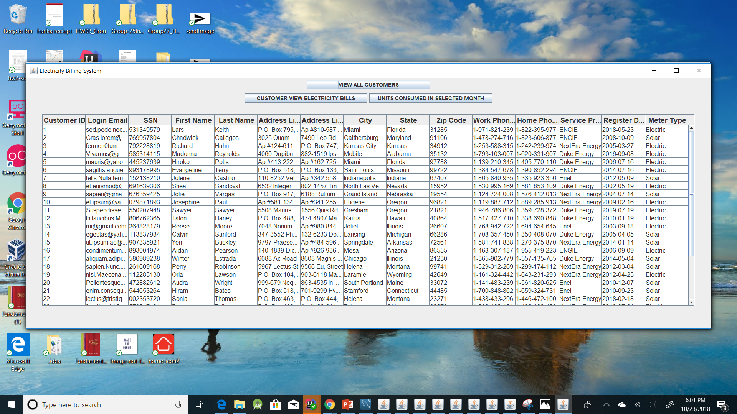

1. Electricity Billing Details of any customer, here for showing we have taken customer having customer_id 1.

**SELECT * FROM Electricity_Billing_Details where customer_id=1;**

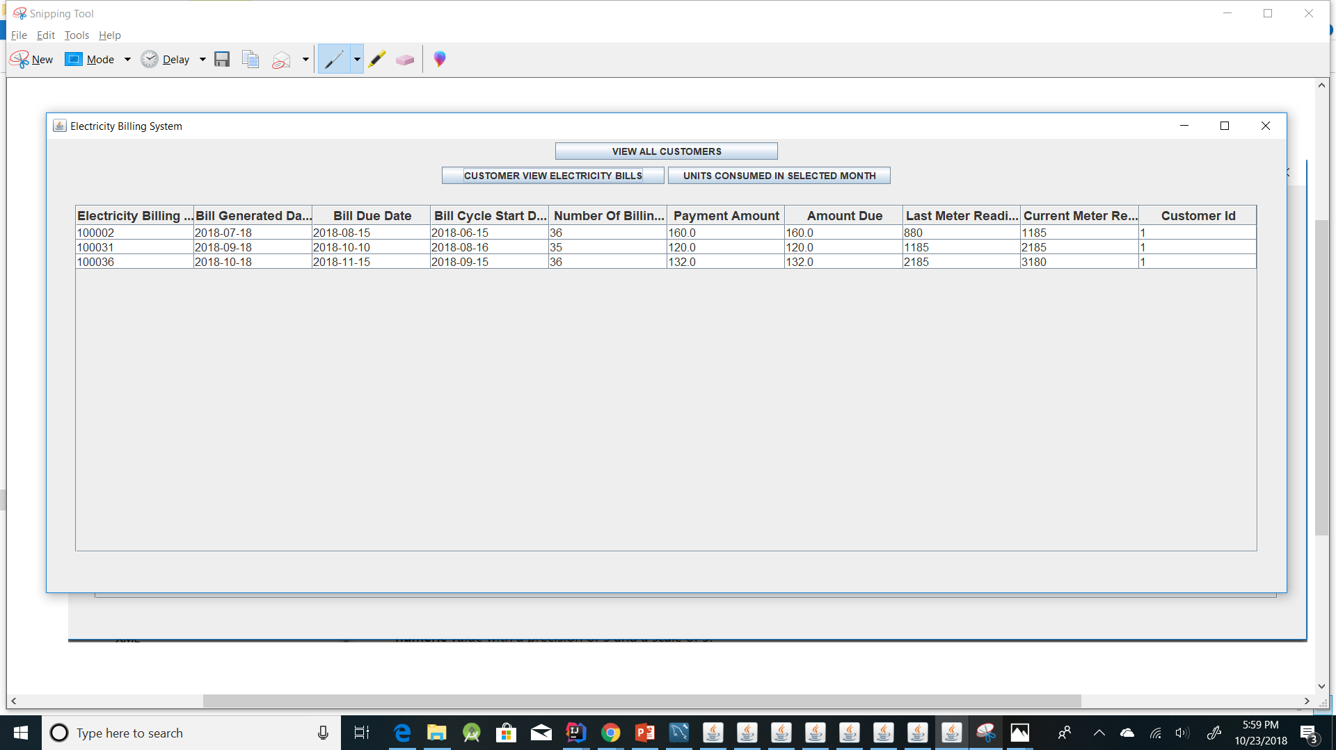

3. Customer view number of units consumed in any selected month. Here we have taken customer having customer_id 1.

**SELECT Electricity_Billing_Details.customer_id, Electricity_Billing_Details.electricity_bill_id, Electricity_Billing_Details.billing_cycle_start_date, last_meter_reading, Electricity_Billing_Details.present_meter_reading, Electricity_Billing_Details.number_of_billing_days, (Electricity_Billing_Details.present_meter_reading-Electricity_Billing_Details.last_meter_reading) as Units_Consumed FROM Electricity_Billing_Details where customer_id=1 AND MONTH(billing_cycle_start_date)=9 AND YEAR(billing_cycle_start_date)=2018;**

